

Flashcards App

Project for Module 226a

Milena Blaser, Blerinë Berisha

AP20a

Table of Contents

Introduction 2

Planning 3

# Introduction

The task of this project is to create an app of our liking. We have decided to program a flashcard app, with which you can study.

In the flashcard app, the user can:

* Create a set

🡪 a set can be added, containing flashcards. i.e., French vocabulary set. There can be several sets saved.

* + Add flashcards

🡪 single flashcards with words and their definitions can be added to a set

* + Remove flashcards

🡪 flashcards can be removed from a set

* + Update flashcards

🡪 definition or word of a flashcard can be changed

* Remove a set
* Go through the flashcards
  + Turn them around

🡪 flashcard can be flipped to show the correct answer

* + Swipe left/right (knew it vs. didn’t know it)

🡪 the user can determine whether or not they knew it and swipe accordingly. Swiping left meaning they knew it and swiping right meaning they didn’t know it.

* Go through the flashcards but by writing the answer on their own

🡪 instead of simply flipping and swiping the flashcards, the answers now have to be written out and will be corrected by the app itself.

* + Click “I don’t know” button to see answer

🡪 if the user doesn’t know the answer, they can click a button, to see the answer.

* + Check answer

🡪 once the user entered an answer, they can check whether it’s correct. The next step is determined by whether or not the answer they entered is correct.

* + - if correct it goes to the next flashcard. You have to get a flashcard correctly twice to have ‘completed’
    - if wrong, the correct answer & spelling will be shown and the user has to repeat the correct answer in order to move on
* show sets

🡪 shows all sets and the number of flashcards in those sets that have been added by the user.

* + show flashcards of a set

🡪 all flashcards of the set can be seen. They’re shown as a list or table, where we can see the index of the word, the word and the definition of it.

# Planning

We created a GitHub repository fairly quickly, after that, we started with our first class diagram. We brainstormed and wrote down what we needed, which we then put into the diagram.

After the first diagram was created, we started to split up tasks to start.

That way we decided that Milena is going to create the diagrams, while Blerinë gets started on the documentation and creates the base structure for the project.

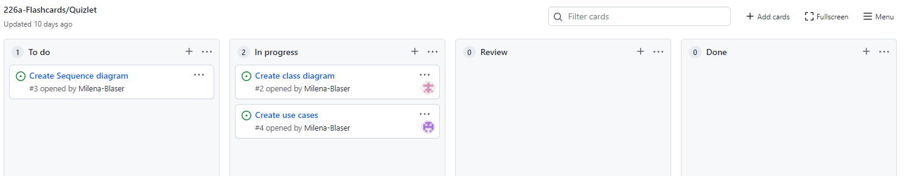

To split the tasks up and make sure we have a good general overview over everything, we created a project in GitHub and opened issues.  
The four columns we created are:

* To do

🡪 Tasks that have to be done for this project, that haven’t been started yet.

* In progress

🡪 Tasks that have been started but aren’t done yet or have been rejected in the “Done” column.

* Review

🡪 Tasks that are done and are currently being reviewed. If there are mistakes or errors, the task will be dragged to “In progress” and the mistakes must be corrected/the task needs improvement.

* Done

🡪 Tasks that are done, have been reviewed and have been accepted.

We kept creating more issues and writing comments, to get a better overview, over what needs to be done in this issue.

We assigned the issues via GitHub.

# Decisions

We decided not to create a GUI but instead give the user a pretty console output.